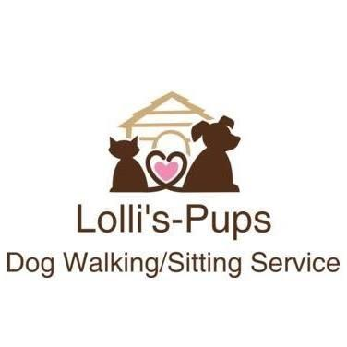
Procedure for Dogs Under 1 Year (Puppy)
All dogs must be screened before being admitted to the premises to ensure that they are not afraid, anxious or stressed in the presence of other dogs or people and do not pose a danger to other dogs or those looking after the dogs at Lolli’s-Pups.
Once a screening has taken place and the dog seems ok to be considered to stay at Lolli’s-Pups, the necessary trial period with all puppies and dogs should be undertaken. This is a trial day for daycare and a trial overnight for boarding overnight.
All puppies must be given suitable and adequate opportunities to:
(a) learn how to interact with people, their own species and other animals where such interaction benefits their welfare.
(b) become habituated to noises, objects and activities in their environment.
Puppies under 1 year will have a restricted exercise regime walking 5 minutes for every month up to 1 year.
They must be housed separately from older dogs unless the owner has given written consent for them to mix with other dogs.
An introduction to other dogs is established gradually where dogs are rewarded for behaving correctly with other dogs. All dogs entering will be initially taken out on a short walk with the other resident dogs at the time. This helps the dogs to understand the pack.
Dogs which need to be kept away from other dogs must be given other forms of mental stimulation. Dogs must receive beneficial human interactions throughout the day and these must be documented on the enrichment register.
All training of puppies under one year of age will be reward based trained and equipment will not cause, pain, stress or fear.
More regular toilet breaks in the garden will be performed for puppies.
Food will be given 3 times per day up to one year (or as per the owner’s instruction).

